- Purpose
  - The purpose of this document is to describe the procedure for assembling the Disk Engagement Plates for the Disk units.
- Scope
  - This SOP applies to all equipment assembly team members. The process applies to the following ID’s:
EP50288EQS0600BE1200 – 20” Disc Head Assembly
- Responsibilities
  - The operations manager/supervisor is responsible for enforcing this SOP.
- Materials
  - The proper materials needed for this process are listed on the machine work order.
- Definitions

- Procedure
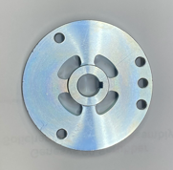
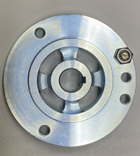
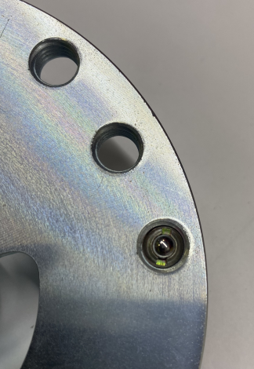
  - Place a Hub Disk Coupler (E29037) with inner circle face up as shown. Put some Blue Loctite on a spring screw (E28910) and thread it through the back side in the 3rd hole on the right (as shown in photo). Thread it in so that the ball end is slightly protruding from the surface. Place nut (E12524) on the backside of the plunger and tighten. This locks it in place.
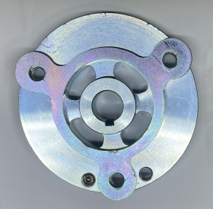
  - Place the spacer plate (E29039) over the middle hole. Then place the retainer disc (E29040) over the spacer as shown. Use 3 flat head screws (E28639) with Blue Loctite to attach. Ensure that it is located on the proper set of holes as shown in the photo.
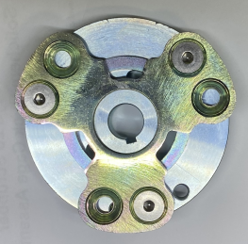

- References (optional section as needed)

- Training Guide

Functional Training Groups Requiring Training
Equipment Assembly Group

- SOP Change Control

Date of Change | Reason for Change
TBD | This is the first version of the S.O.P. hence there are no revisions to this document.
8/13/2021 | Added QC Check and torque check.
4/1/2025 | Revision some of the language

Approvals

Submitter/Author Approval:__________________________________ Date:______________________

Management Approval:______________________________________ Date:______________________

QAU Approval:_____________________________________________ Date:______________________

